4-2 Project One: Part Two

DAT-430

Ashley Littles

Southern New Hampshire University

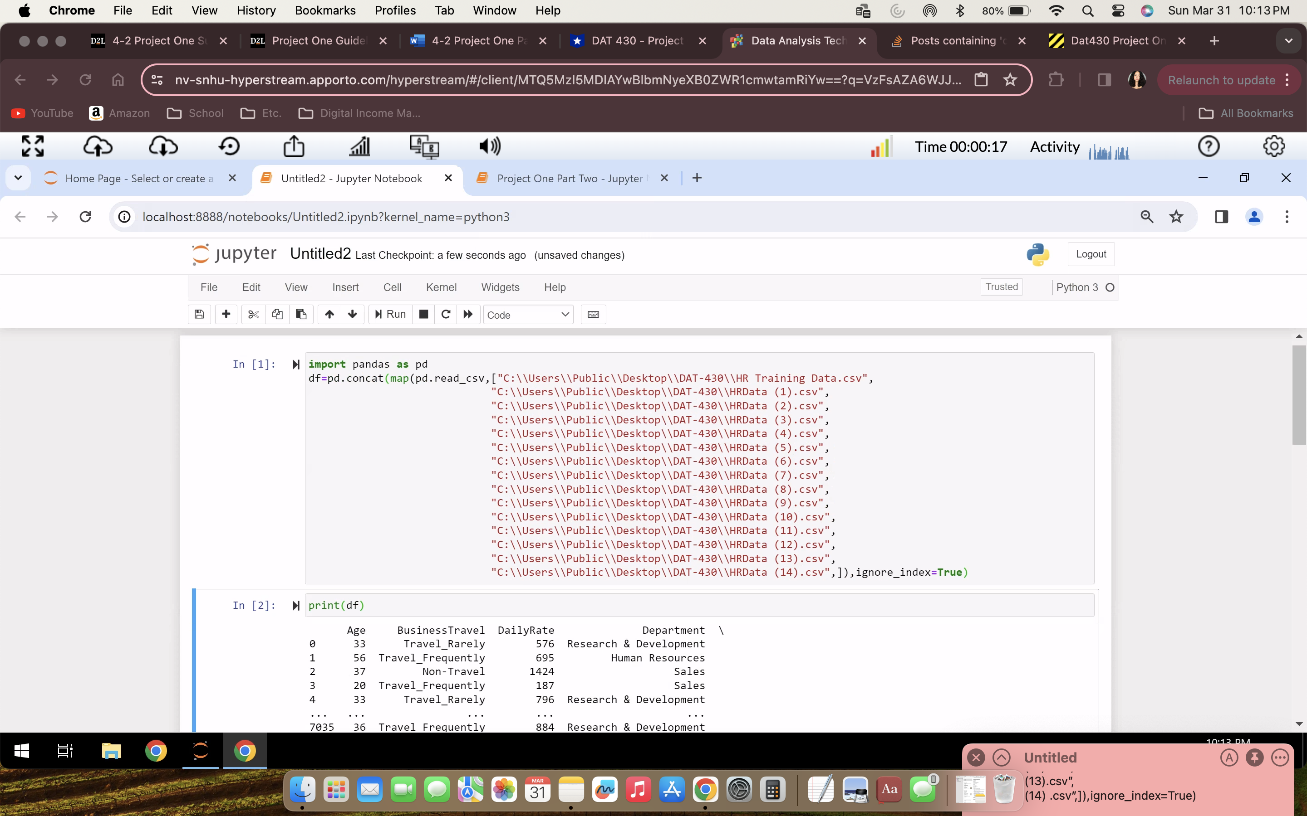

To begin merging the data sets we will import panda and then use the df=pd.concat(map) command to load all of the csv files for analysis.

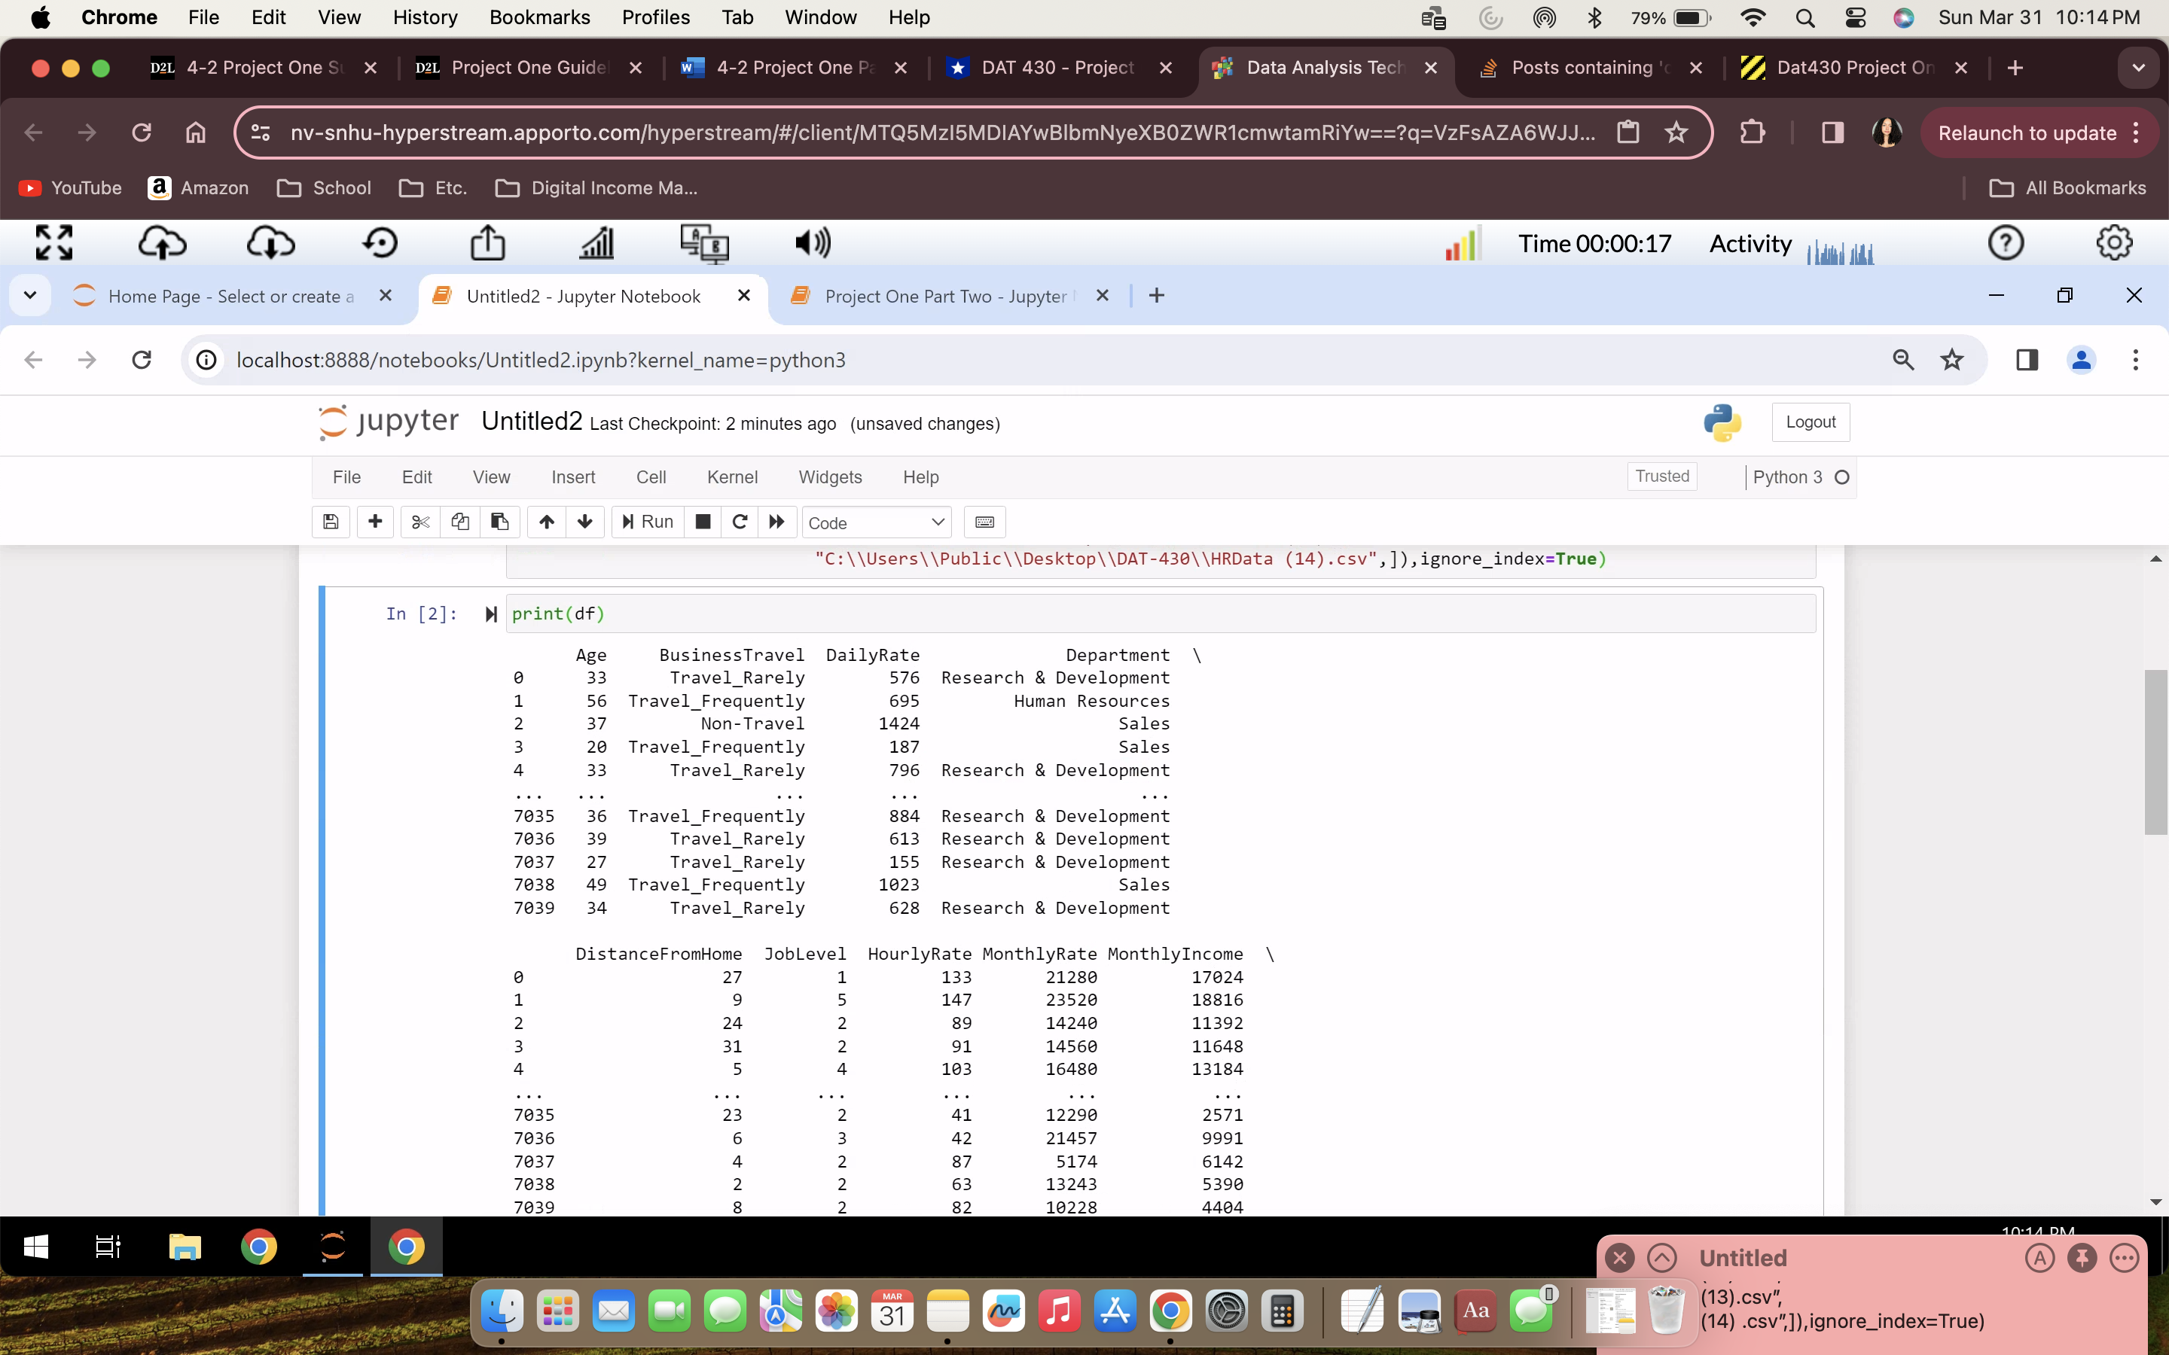

Next, we use the command print(df) to display the data set.

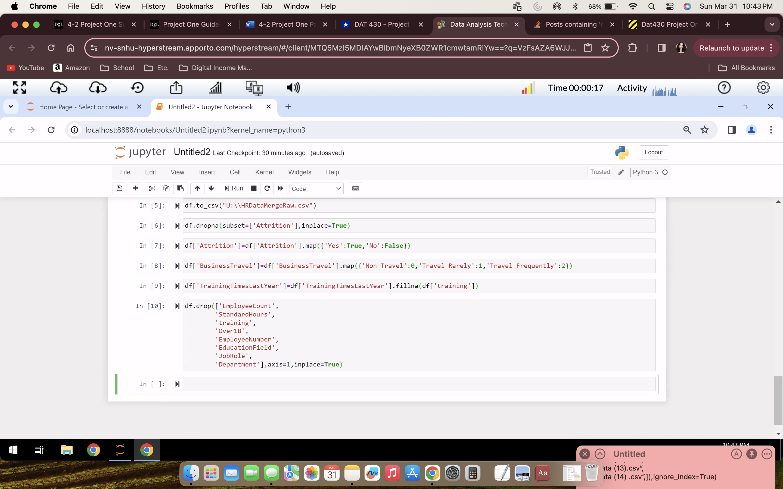

We then export the .csv file and make changes to the data set such as removing null values, updating string to number values, and removing any duplicate data.

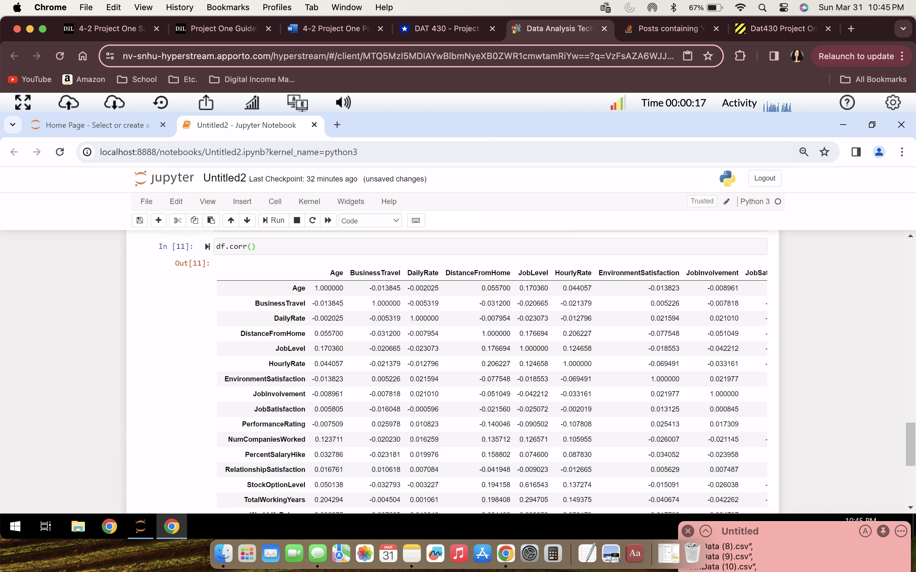

We then can display the results of the changes shown above.

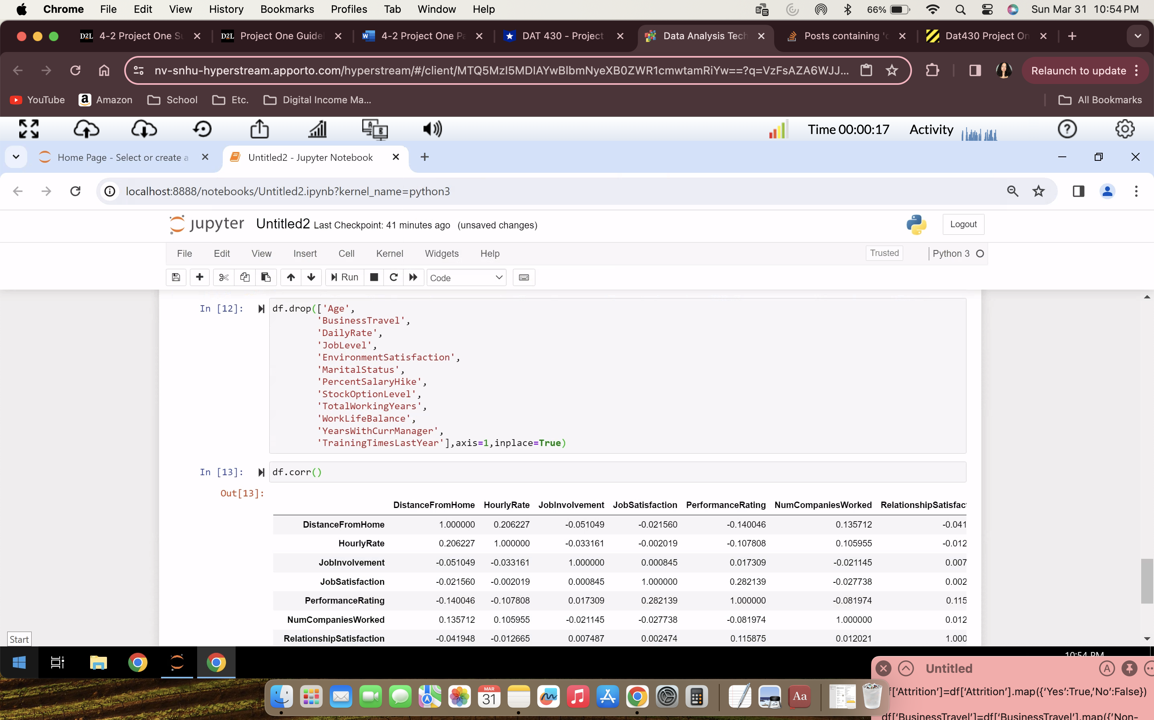

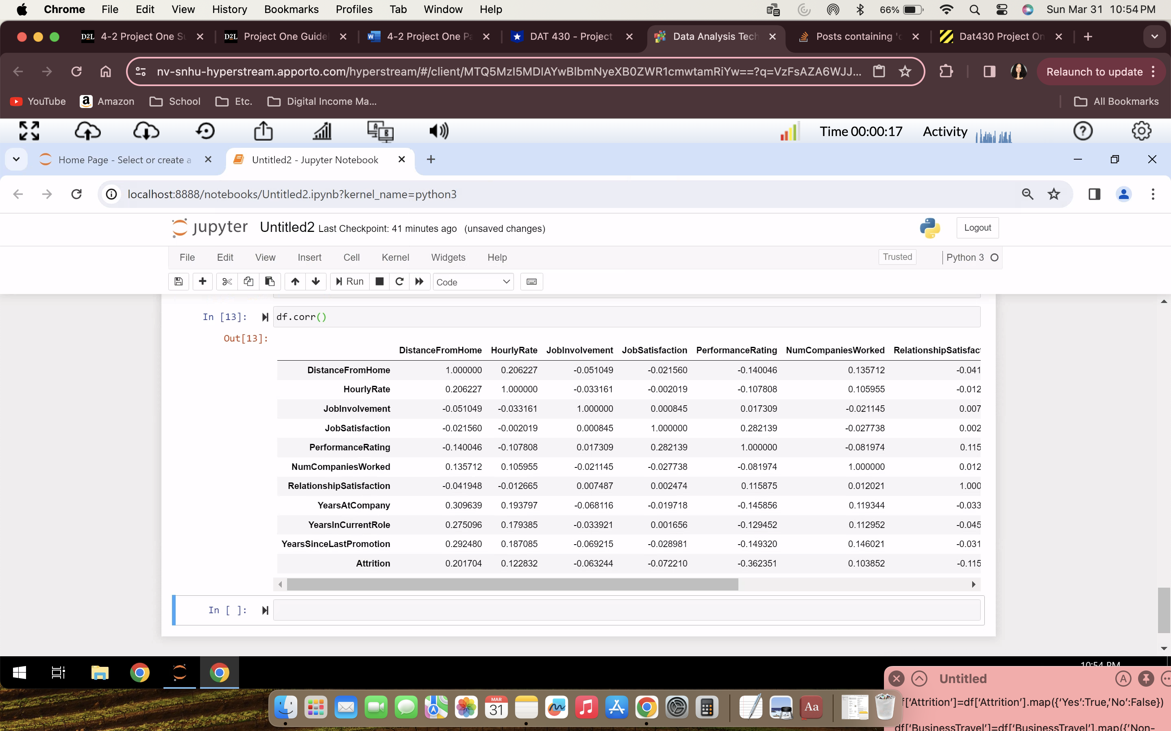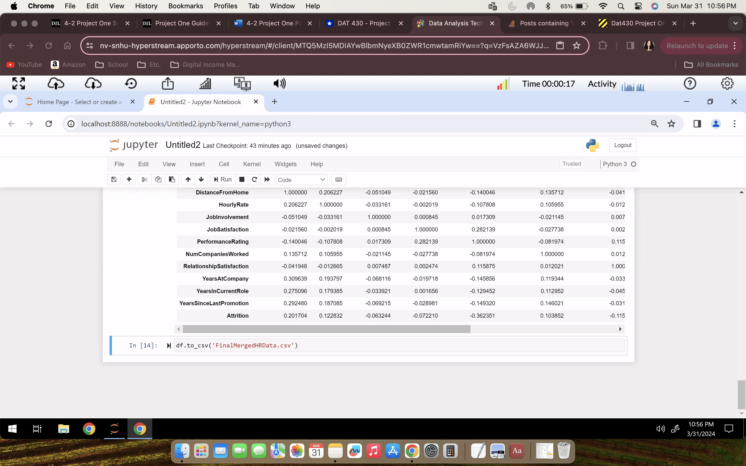

Lastly, we will rerun the analysis and confirm the changes and prepare the data to be put into a visualization. As well as create the final merged data csv.